Lesson 6 b
- Answer the questions in your notebooks: What teen camps do you know? GIVE FULL ANSWERS (4 sentences)
а)
b)
С)
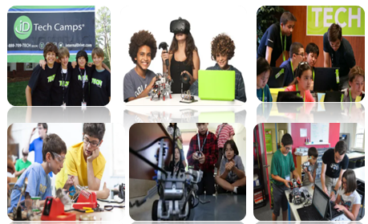
d)

2)Look at the pictures, make up 14 sentences as in the scheme: “ If _____ ____Present Simple_____ , _______ ___Future Simple____ “. Every time choose different subjects(подлежащее) (pronouns are forbidden!)
3Read the dialogue( SB p 58 ex 2) . Write out into your notebooks:
- 4 sentences with Present Perfect
- 2 sentences with Present Continuous
- 3 sentences with Present Simple with the verb «to be»
- 3 sentence with Present Simple (without “to be”)
- 2 sentences with conditional clause (if)
- 1 sentence with a modal verb
4)EXPLAIN (not translate!) in your own words the meaning of the last sentence (IN ENGLISH)
HOME ASSIGNMENT:
1)Слова 6 модуля (письменно)
2)2)SB p 58 ex 2: прослушать аудио, обращая внимание на интонацию и произношение, отработать правильное звучание, учить (весь) диалог наизусть к пятнице
3)WB p 36 ex 1-3
4)Быть готовыми к описанию картинки (ВПР)

ВЫСЛАТЬ ФОТО КЛАССНОЙ РАБОТЫ НЕ ПОЗДНЕЕ 31.01 ДО 18:00

